Adaptive Release Advanced for Assignments
Adaptive Release: Advanced allows you to choose for an assignment to be released to only a specific student and/or only during a specific time. You may use this in the case of a Centre for Accessibility Services (CAS) accommodation.
Make sure edit mode is on
(Top right of screen)
Edit Mode is ON | Click to toggle. | Edit Mode is Off
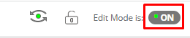 | 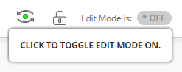 | 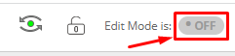

- Go to your assignment and click the down arrow to the right of the title.
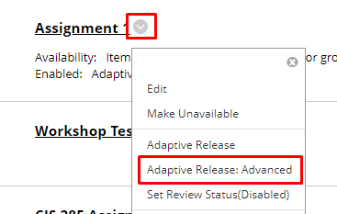
- Click Adaptive Release: Advanced.
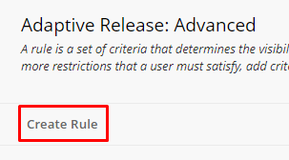
- Click Create Rule.
- Type the rule in the name box and click Submit.

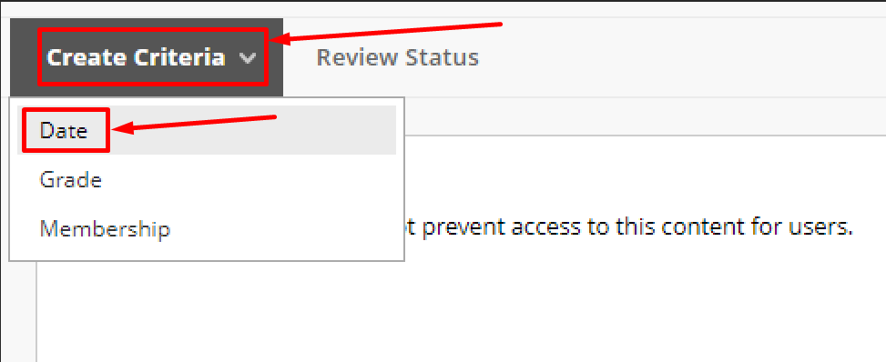
- Click Create Criteria and choose Date
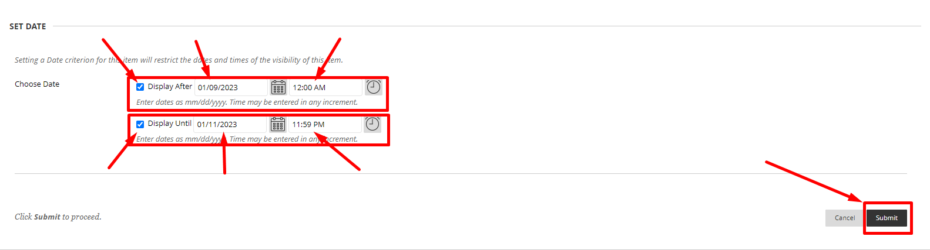
- Set the dates for the assignment to be visible to the student and click Submit.

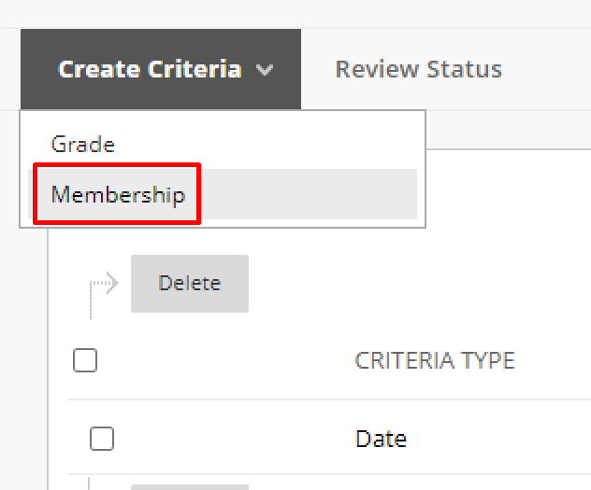
- Click Create Criteria and choose Membership
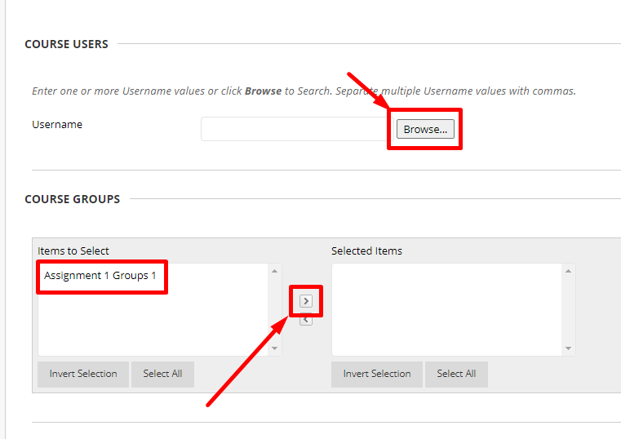
- Click Browse to find the student or click on the group and press the right arrow in the middle.
- Check the box next to at least one student and click Submit.
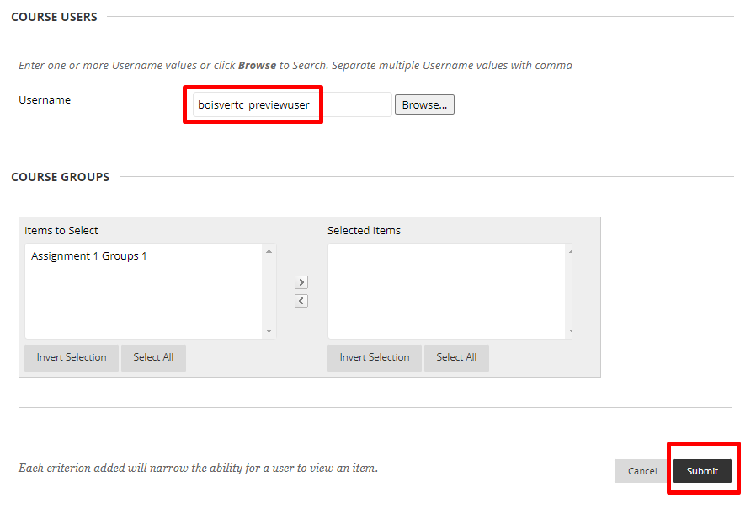
- Check that the student appeared and click Submit.

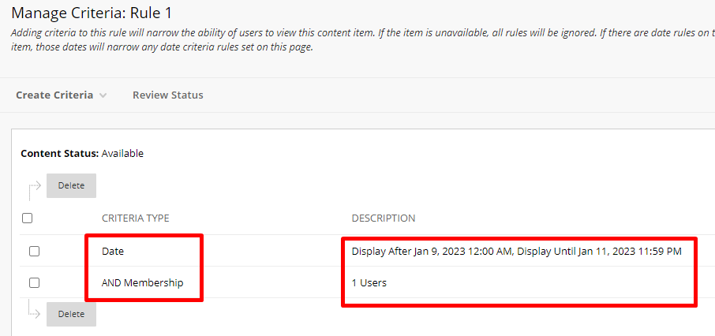
- Check that the date and membership information is correct

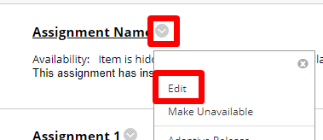
- Go back to the assignment and click the down arrow to the right and choose Edit.
- Make sure that the assignment is available and DO NOT select display after and/or display until as it may cause a conflict with the adaptive release.
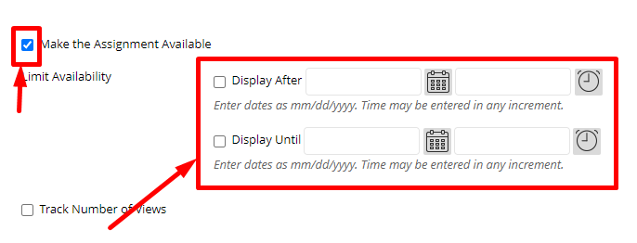

Interested in more educational tools? Check out our How-To Guides at: www.ufv.ca/myclass/faculty-centre/faculty-tutorials or email us at asktlc@ufv.ca

