Clear Submitted Assignments
Make sure edit mode is on
(Top right of screen)
Edit Mode is ON | Click to toggle. | Edit Mode is Off
 | 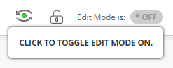 | 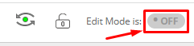
You can clear a students attempt on an assignment so they can re-submit it.
This can offer usually be prevented by providing students multiple attempts at an assignment.

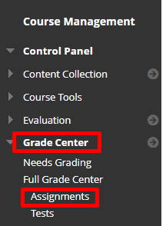
- On the left menu under Course Management click Grade Center and Assignments.

- Move the mouse to the right of the graded or ungraded submission and you will see a down arrow.
- Click View Grade Details
Graded submission | Ungraded submission
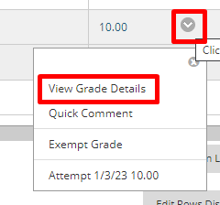 | 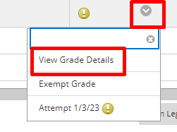

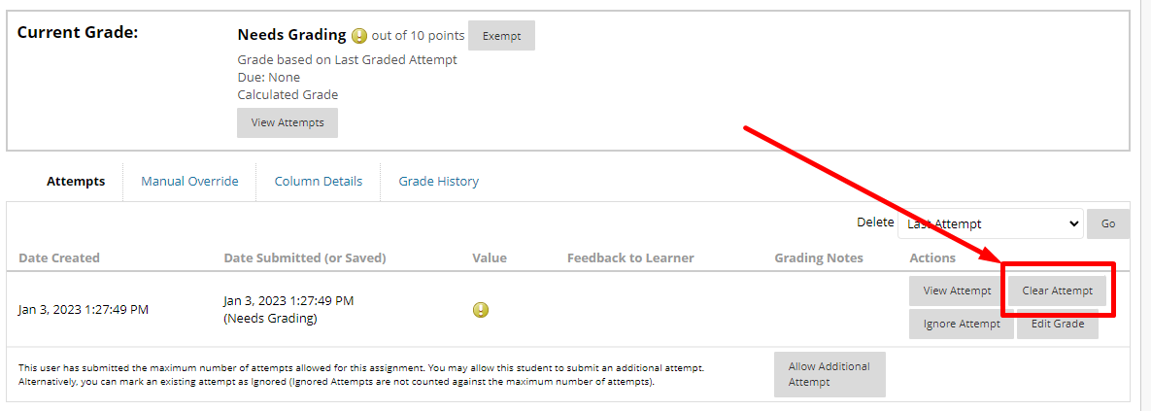
- Click Clear Attempt
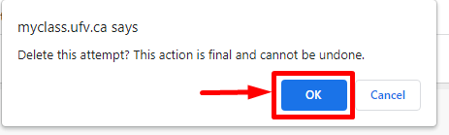
- Confirm that you want to delete the attempt.
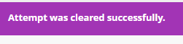
- You will see a notice at the top of your window that states the attempt was cleared successfully and you will be directed back to the grade info.

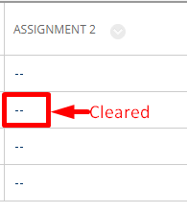
- Go back to the grade centre and see that the attempt has been cleared.

Interested in more educational tools? Check out our How-To Guides at: www.ufv.ca/myclass/faculty-centre/faculty-tutorials or email us at asktlc@ufv.ca

