Create Content Folders
Make sure edit mode is on
(Top right of screen)
Edit Mode is ON | Click to toggle. | Edit Mode is Off
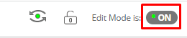 | 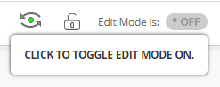 | 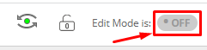
You can create content folders to hold weekly materials or materials that are under the same topic.

- Navigate to your course content page on the left menu.
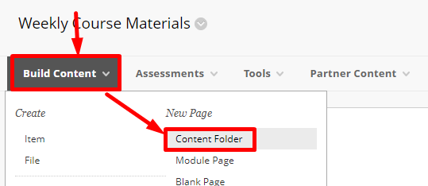
- Click Build Content and choose Content Folder.
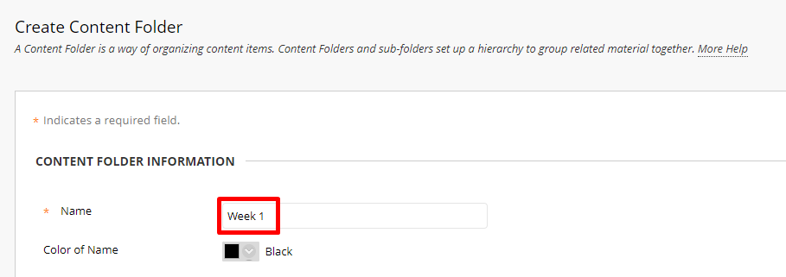
- Choose a name for your content folder.

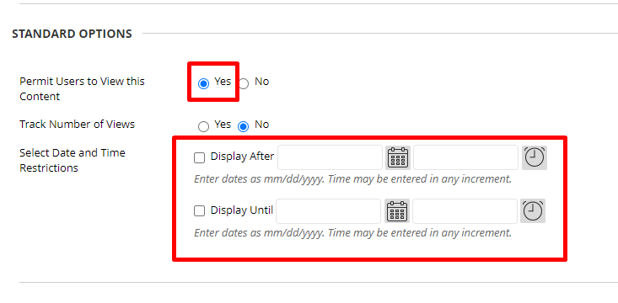
- Make sure you have permitted users to view the content. You can also set a display after or display until date to hide the folder outside of specific dates.
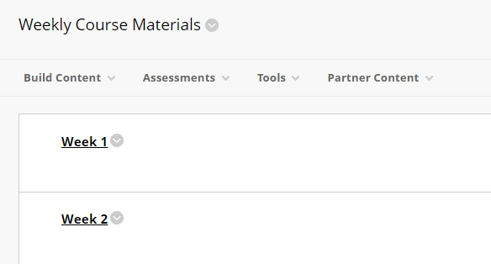
- Your multiple content folders will be on your course content page.

Interested in more educational tools? Check out our How-To Guides at: www.ufv.ca/myclass/faculty-centre/faculty-tutorials or email us at asktlc@ufv.ca

