Download Grades
Make sure edit mode is on
(Top right of screen)
Edit Mode is ON | Click to toggle. | Edit Mode is Off
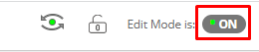 | 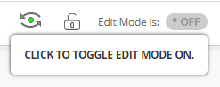 | 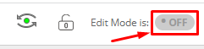
Downloading grades allows you to download an excel document to work with student grades offline.

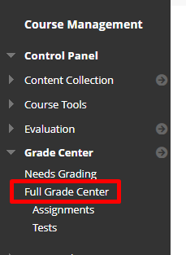
- On the left menu click on Grade Center then Full Grade Center.
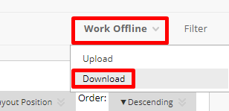
- On the right hand side click Work Offline and then press Download.
- Choose the data that you would like to download. Usually you want the Full Grade Center.
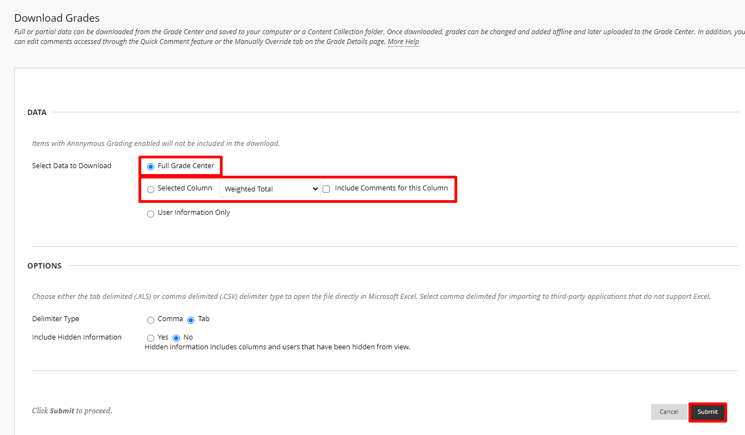
- Press Submit.
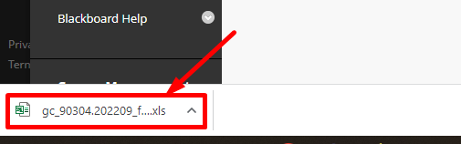
- If you are using Chrome it should download and show up on the bottom left hand of your window.
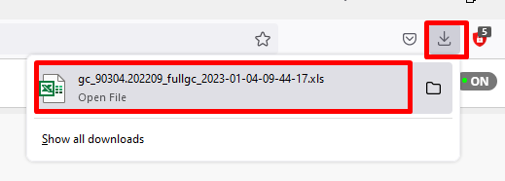
- If you are using Firefox it will download and show up in the top right.

Interested in more educational tools? Check out our How-To Guides at: www.ufv.ca/myclass/faculty-centre/faculty-tutorials or email us at asktlc@ufv.ca

