Test Exceptions
Make sure edit mode is on
(Top right of screen)
Edit Mode is ON | Click to toggle. | Edit Mode is Off
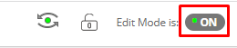 | 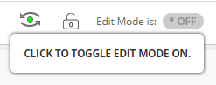 | 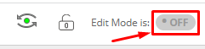
You can set exceptions on a test that allow you to provide a single student with different parameters for the test such as availability, timer and/or number of attempts.

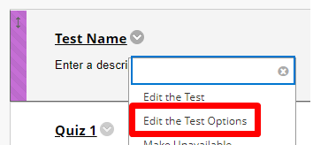
- Go to the test you want to add the exception to and choose Edit the Test Options.
- Click Add User or Group.
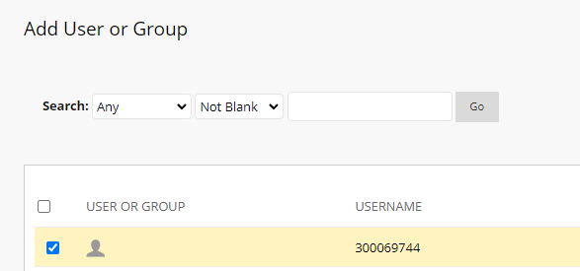
- Choose the student you wish to set the exception for.
- Set the exceptions for that student
  - Choose the number of attempts the student has.
  - Set the timer for this student.
  - Choose if auto-submit is activated or not.
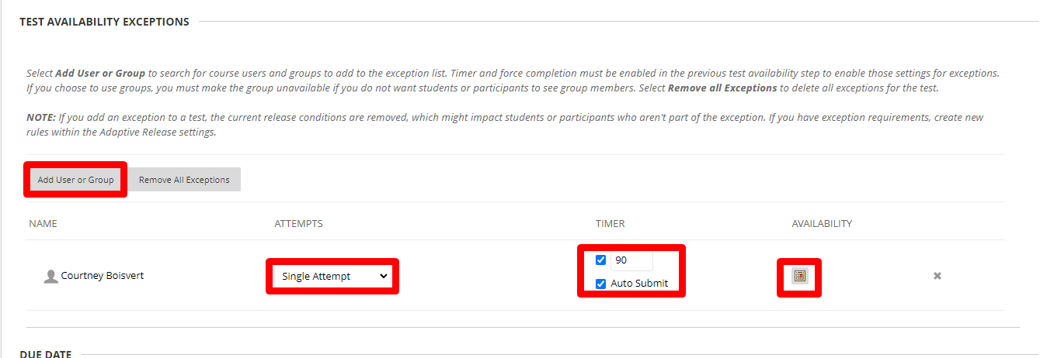
  - Click the calendar to edit the availability dates of the test.

Interested in more educational tools? Check out our How-To Guides at: www.ufv.ca/myclass/faculty-centre/faculty-tutorials or email us at asktlc@ufv.ca

