Troubleshooting tips for Instructors
Here are some troubleshooting trips for some common problems that instructors encounter in Blackboard.
Preventing problems first:
- Use a fast, wired internet connection. If you are using a wireless connection, ensure it is a secure one (like EduRoam) and put your computer as close to the router as possible.
- Do not use Internet Explorer or Edge. Install the latest version of Google Chrome or Mozilla Firefox.
- Before you type in content in Blackboard. Type and save them in Word (or any text editor) first. Then you can copy the content into Blackboard.
Common Problems
- Old content is showing
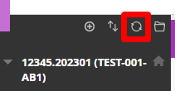
  - Click the “Refresh” icon.
  - If the browser automatically logged you in, sign out and sign back in again.
  - If the Refresh button doesn’t solve the problem. Shut down your computer and turn it on again.
  - If it still doesn’t work use another browser like Chrome or Firefox.
- Uploading problem – Upload will not complete or is too slow.
  - Test upload a smaller document, if it works break your content down into smaller sections.
  - If a smaller item doesn’t work try uploading from a different computer or
faster internet connection.

- Editing problem – You cannot see the option to add content.
Make sure edit mode is on
(Top right of screen)
Edit Mode is ON | Click to toggle. | Edit Mode is Off
 | 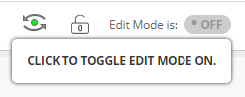 | 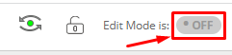
  - Make sure edit mode is on.

Interested in more educational tools? Check out our How-To Guides at: www.ufv.ca/myclass/faculty-centre/faculty-tutorials or email us at asktlc@ufv.ca

