Teaching and Learning (TLC) Logo


Course List

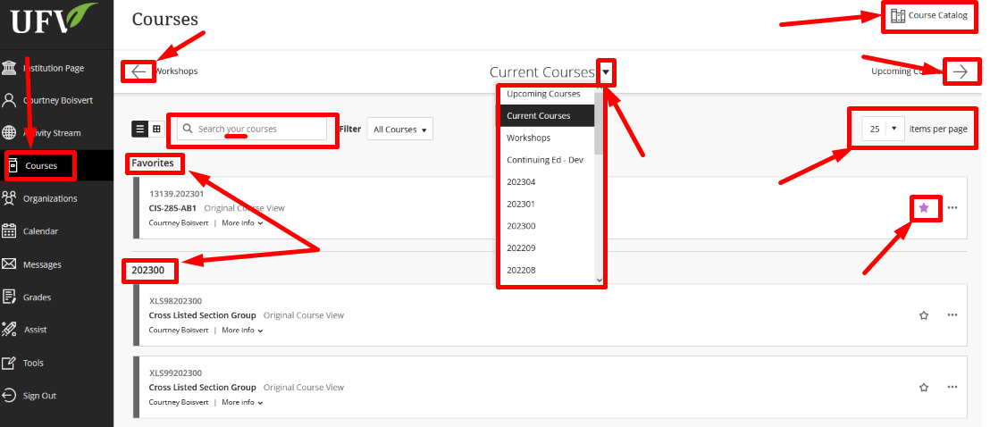When you open blackboard, you will be brought to the Institution page. Click on Courses on the left hand side and you will be brought to your courses page.

**1. Courses page 2. Go to previous semester 3. Jump to a different semester 4. View the course catalog 5. Go to next semester 6. Search your courses. (Only your courses) 7. Number of courses displayed per page. 8. Favourites 9. Add to Favourites 10. Semester of courses**

**9**

**8, 10**

**7**

**6**

**5**

**4**

**3**

**2**

**1**

Interested in more educational tools? Check out our How-To Guides at: [www.ufv.ca/myclass/faculty-centre/faculty-tutorials](http://www.ufv.ca/myclass/faculty-centre/faculty-tutorials) or email us at [asktlc@ufv.ca](mailto:asktlc@ufv.ca)

