How to Download Assignment Files
Make sure edit mode is on
(Top right of screen)
Edit Mode is ON | Click to toggle. | Edit Mode is Off
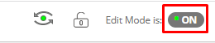 | 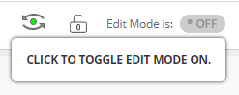 | 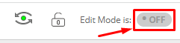
This allows you to download submitted student files to your computer to make for easier marking.
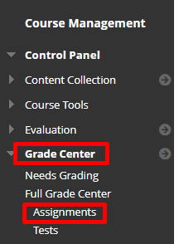
- Click Grade Centre then click Assignments.
- Find the Assignment title in the grade centre and click on the arrow next to the assignment name. Click Assignment File Download.
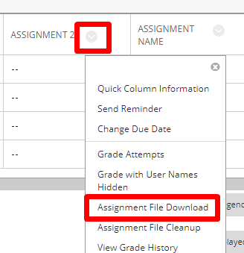

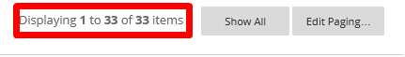
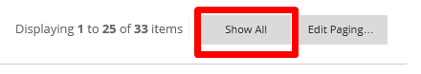
- Check if all students are appearing. If not press Show All

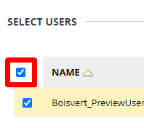
- Once all the users are appearing choose Select All Users
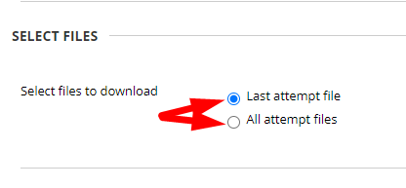
- Select Last attempt file in order to only get one file for each student. All attempt files will provide you with each submission the student made of their multiple attempts.
- Press Submit.
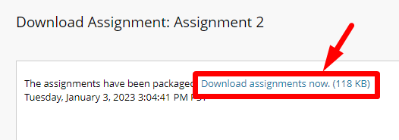
- The screen will proceed to a Download Assignment window saying the assignments have been packaged. Click Download now

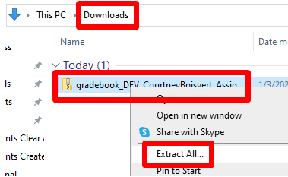
- Open your computers downloads folder and right-click on the downloaded zip file.
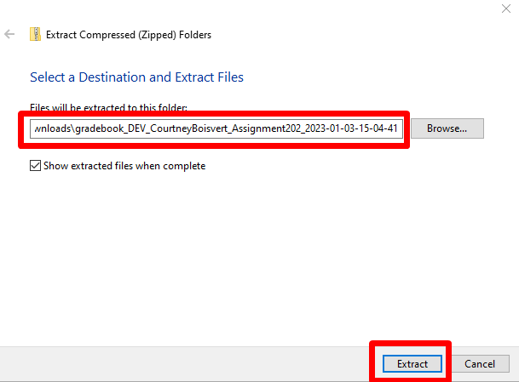
- Choose an appropriate location to save the extracted files to and click Extract.

- Go to the location you just chose and choose the new unzipped folder.
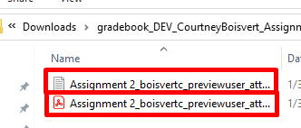
- You will see two files, one txt file that contains the submission information and a second other file of any format that the student has submitted for the assignment.

Interested in more educational tools? Check out our How-To Guides at: www.ufv.ca/myclass/faculty-centre/faculty-tutorials or email us at asktlc@ufv.ca

