How to Export and Import Tests
Make sure edit mode is on
(Top right of screen)
Edit Mode is ON | Click to toggle. | Edit Mode is Off
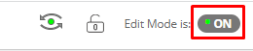 | 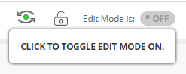 | 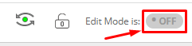
You can export your tests to a blackboard file that you can later import to move tests from one course to another. This can also be done with Course Copy and ensuring Tests, Surveys, and Pools is checked to copy.

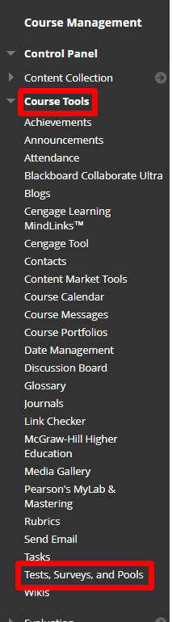
- Go to Course Tools Tests, Surveys and Pools
- Click Tests

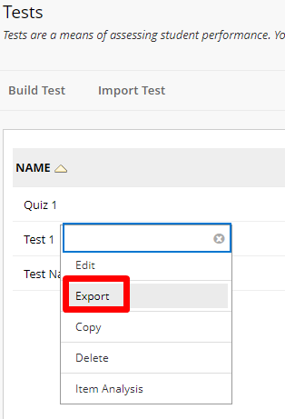
- Choose the arrow next to the test you want to export and choose Export.

To import
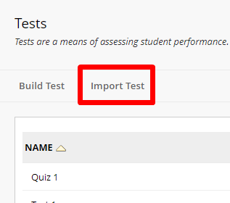
- Go to the shell you want to import the test into and go back to Course Tools Tests, Surveys, and Pools Tests and Click Import Tests
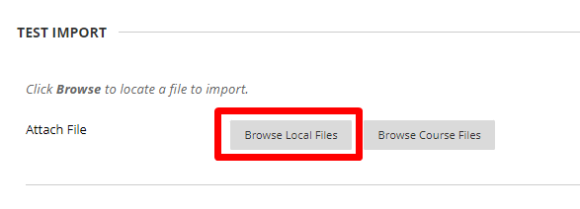
- Click Browse Local Files
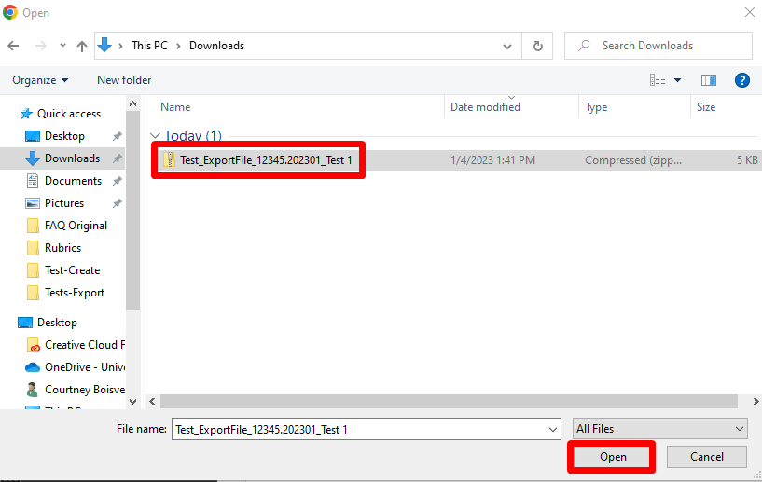
- Find the Exported Test and click Open
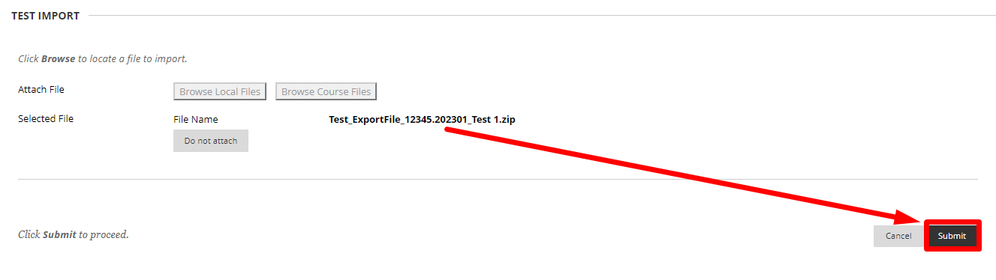
- Press Submit
- The Test Import Complete window will appear press OK.
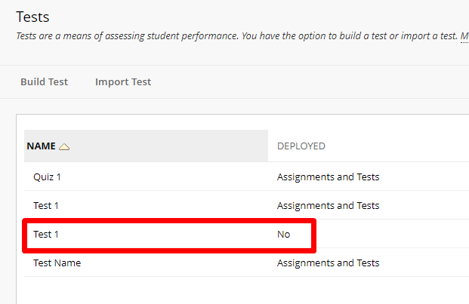
- View that the test is entered and Deployed currently says No.

Interested in more educational tools? Check out our How-To Guides at: www.ufv.ca/myclass/faculty-centre/faculty-tutorials or email us at asktlc@ufv.ca
