How to Grade Assignments
Make sure edit mode is on
(Top right of screen)
Edit Mode is ON | Click to toggle. | Edit Mode is Off
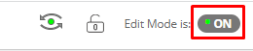 | 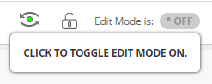 | 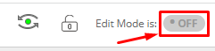
This allows you to grade assignments that students have submitted via the assignment dropbox.

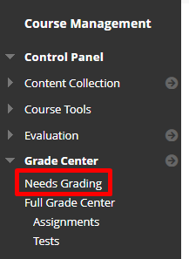
- Click Grade Centre then click Needs Grading.

- The attempts will appear for you to choose which student you would like to grade.
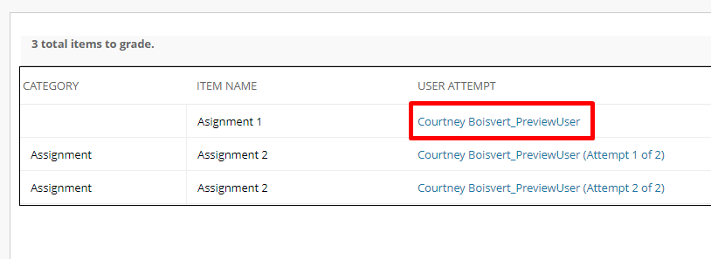
- Click on the User Attempt you wish to view.
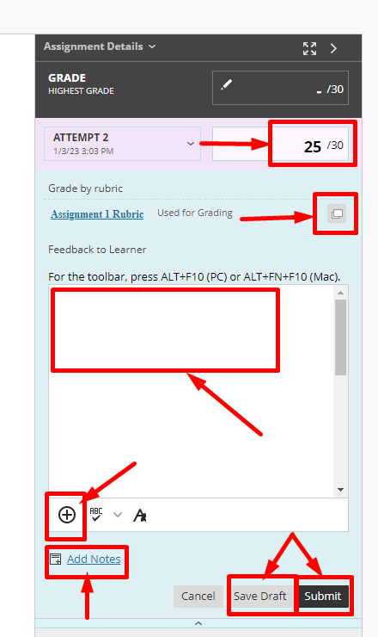
- Click the arrow to expand the grading panel or click the download button to download a copy of this single assignment.
- In Attempt you can type the score they received or you can open the rubric and mark using the rubric and after which the rubric’s score will enter into the attempt.
- You can provide feedback, including adding Mashups for video and audio feedback.
- You can add notes for the instructor
- You can save the draft or press submit to make the grade live.

Interested in more educational tools? Check out our How-To Guides at: www.ufv.ca/myclass/faculty-centre/faculty-tutorials or email us at asktlc@ufv.ca

