Setting Course Availability
Make sure edit mode is on
(Top right of screen)
Edit Mode is ON | Click to toggle. | Edit Mode is Off
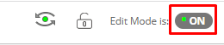 | 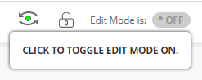 | 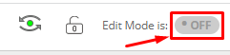
If you need your course availability to be different than the current term. (Shorter or longer) you can change the course availability.

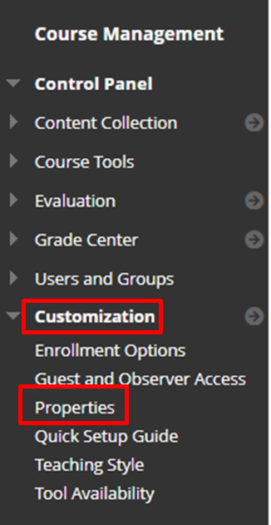
- Go to Course Management Customization Properties.

- Check Make Course Available Yes
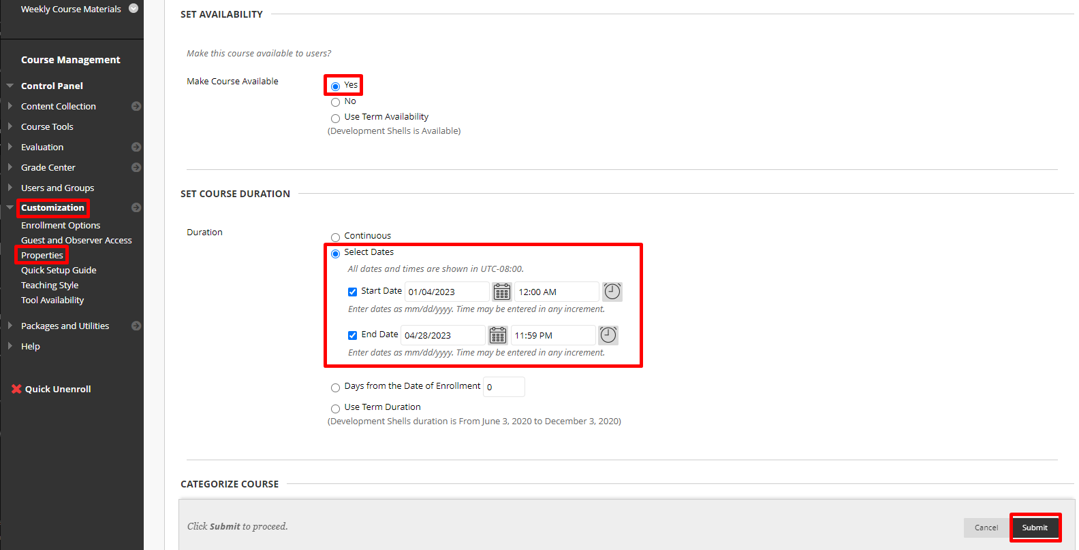
- Set Dates for course duration.
- Click Submit

Interested in more educational tools? Check out our How-To Guides at: www.ufv.ca/myclass/faculty-centre/faculty-tutorials or email us at asktlc@ufv.ca

