Test as Assignment with Time Limit
Make sure edit mode is on
(Top right of screen)
Edit Mode is ON | Click to toggle. | Edit Mode is Off
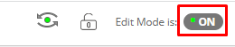 | 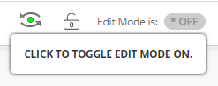 | 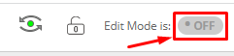
You can administer a test to have an assignment with a time limit. They both allow for instructor feedback including document, video and/or audio.

- Things to note between a test with a file upload option or an assignment.
 | Test with File Upload | Assignment
Set timer for submissions | Yes  Test Options Set Timer On | No.  (Display after & until only)
Download All Submissions in One Zip File | No | Yes  Assignment File Download
Download One Submission at a time on One Page with All Submissions | Yes  Grade Questions Responses | No
Download One Submission in “View Attempts” | Yes | Yes
Instructors Feedback Document | Yes | Yes
Instructor’s Feedback Video/Audio | Yes  Via Kaltura Media (Bigger files are okay) | Yes  Via File Attachment (Small files only)

Test with File Response Question:
- Go to Full Grade Center, click on the arrow next to the Test. Click Grade Questions
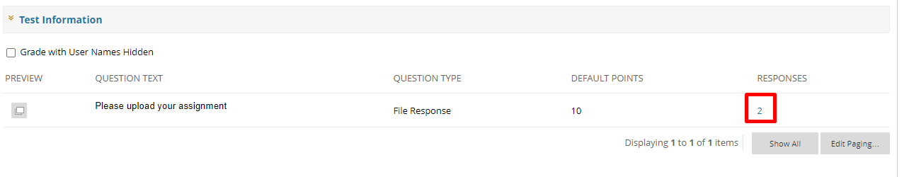
- Click on the number under Responses.
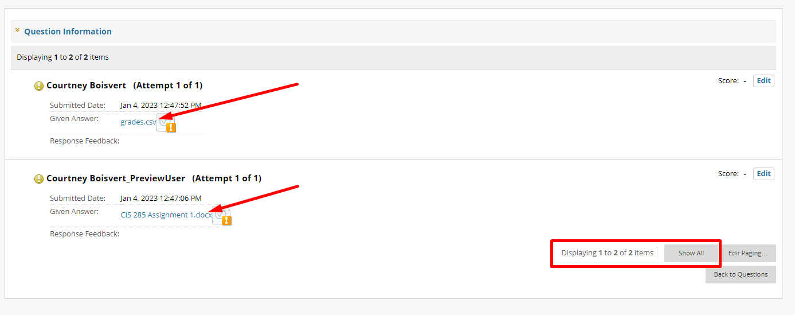
- Download One submission at a time on one page with all submissions.

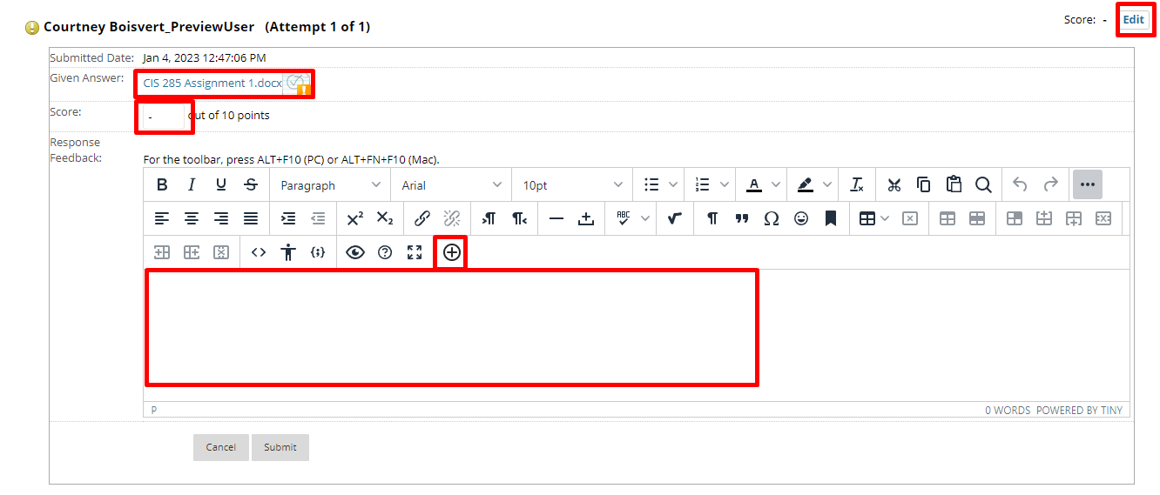
- In the Feedback and notes for attempt attach the instructor’s feedback

Interested in more educational tools? Check out our How-To Guides at: www.ufv.ca/myclass/faculty-centre/faculty-tutorials or email us at asktlc@ufv.ca

