Upload Grades
Make sure edit mode is on
(Top right of screen)
Edit Mode is ON | Click to toggle. | Edit Mode is Off
 | 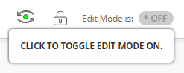 | 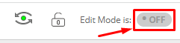
Uploading grades allows you to upload an excel document after working with student grades offline.

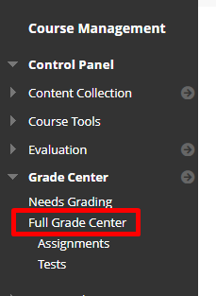
- On the left menu click on Grade Center then Full Grade Center.
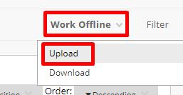
- On the right hand side click Work Offline and then press Upload.
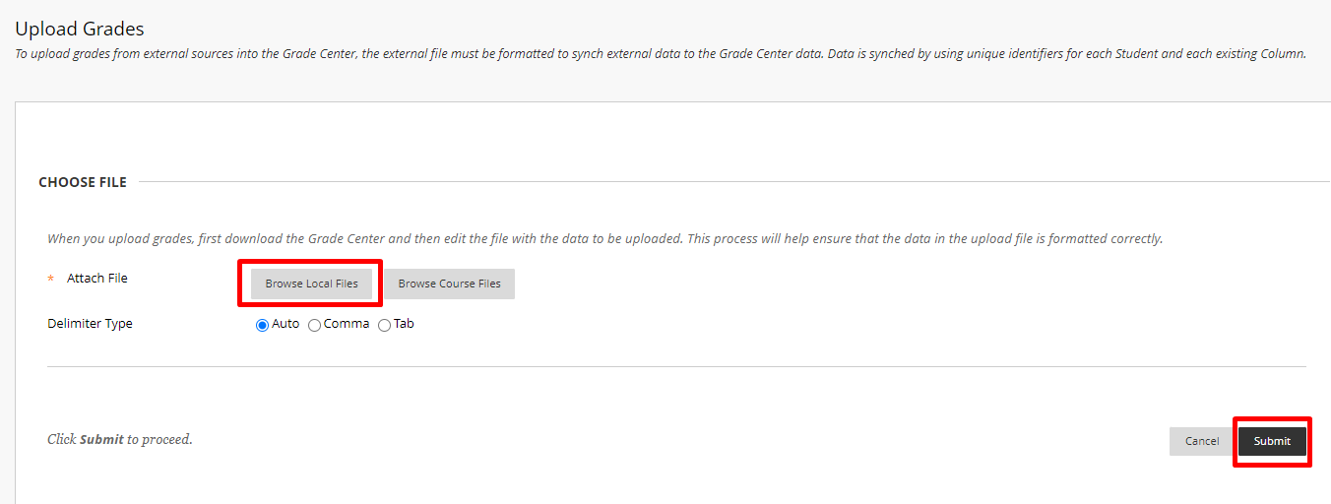
- Choose browse local files
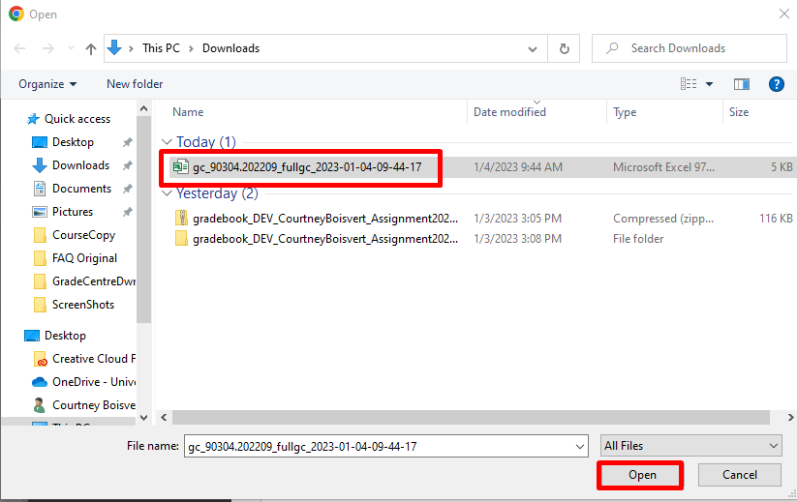
- Find the file you would like to upload.

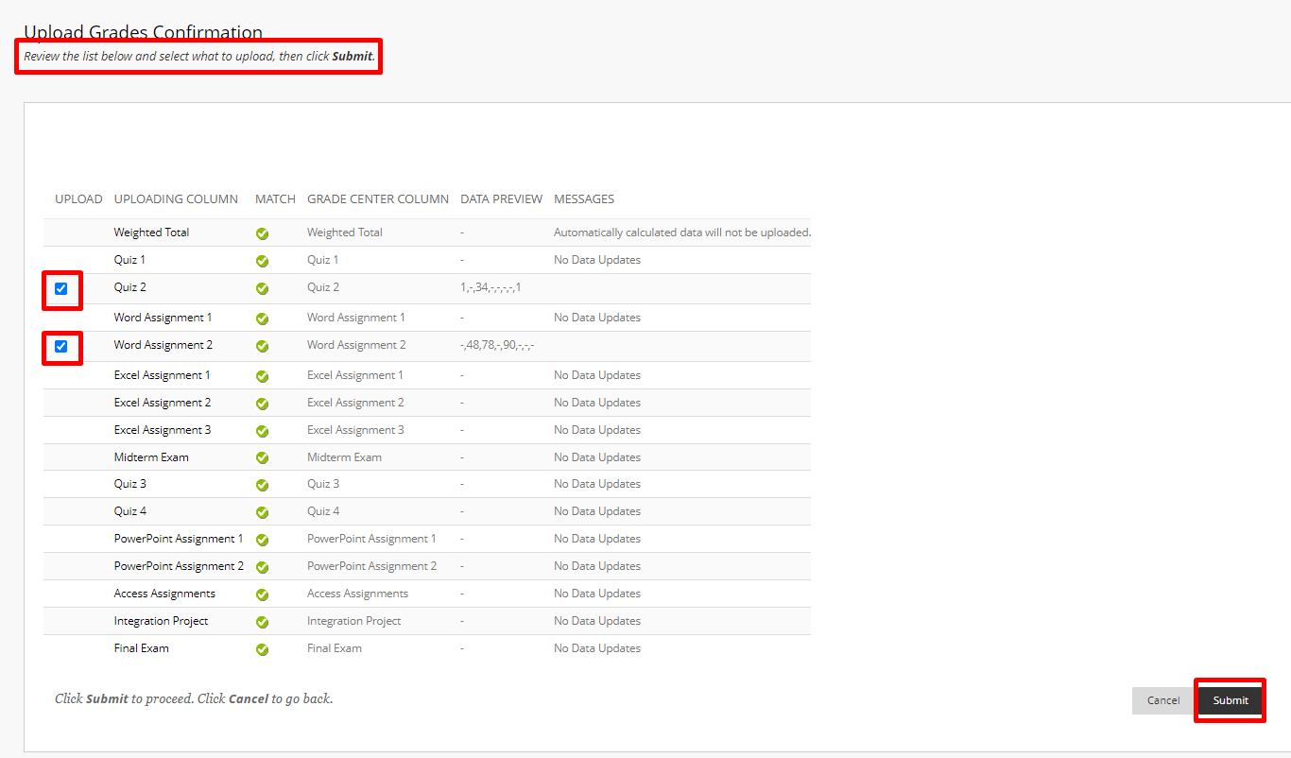
- Review the grade center items that will change from the uploaded file and press submit.

Interested in more educational tools? Check out our How-To Guides at: www.ufv.ca/myclass/faculty-centre/faculty-tutorials or email us at asktlc@ufv.ca

