Zoom – Account Portal for UFV Users

Email: askTLC@ufv.ca Video: video.ufv.ca

1] ufv-ca.zoom.us > Sign In

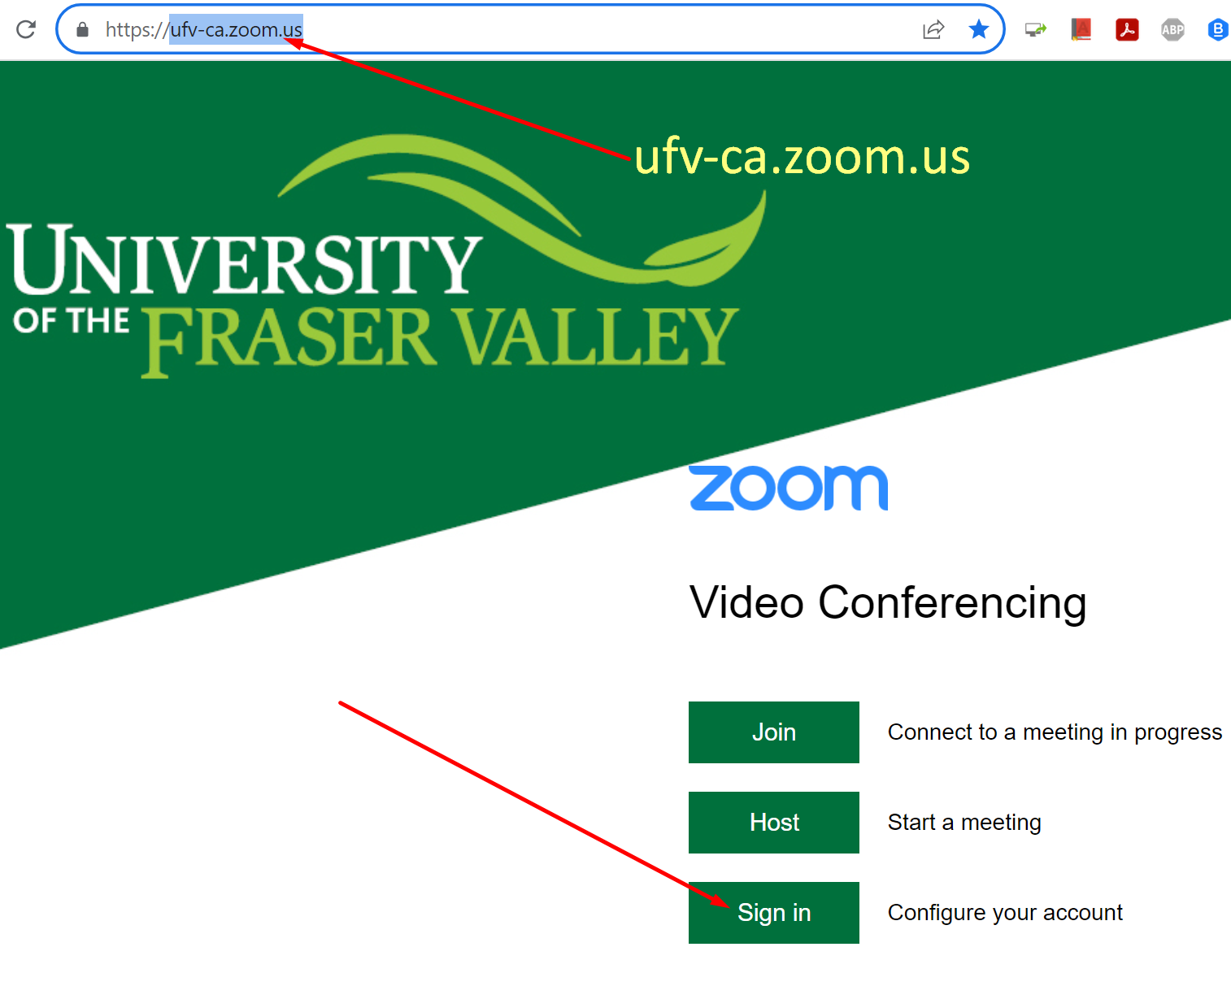

2] Log in with your UFV email address and password.

3] Check the menu items on the left

Profile: Avatar, Display Name, etc.
Meetings: Edit some options for each meeting.
Webinars: Contact IT for large-scale webinars.
Personal Contacts: Zoom’s own contact list.
Whiteboards: “My Whiteboards” can be saved.
Recordings: “Cloud Recordings” > “Share”.
Scheduler: Not Available.
Settings: These settings affect each meeting.
Reports: “Usage Reports” > “Usage” for meeting logs.
Account Profile: Basic Zoom account information.

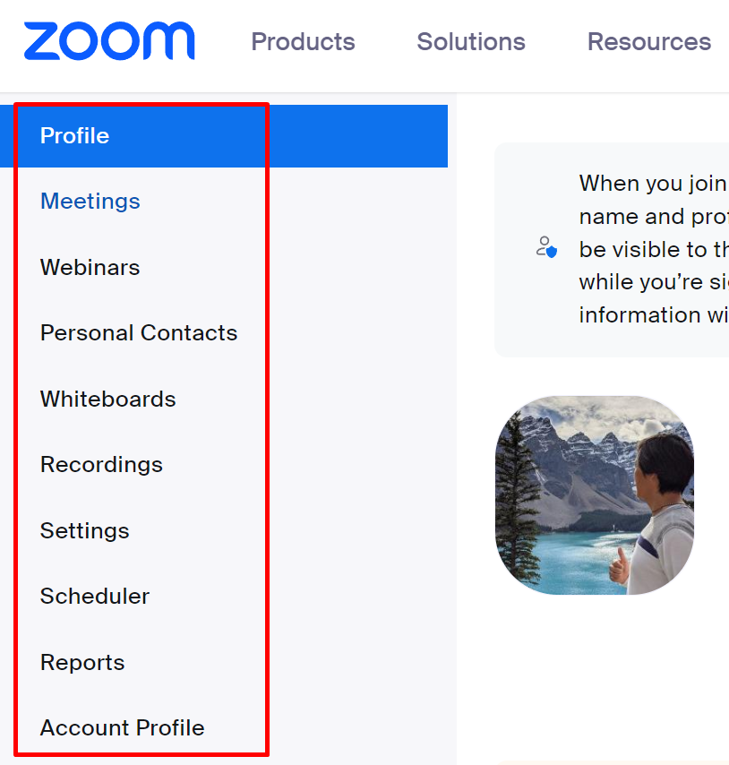

Revised by Soowook Kim on SEP 01, 2023.

