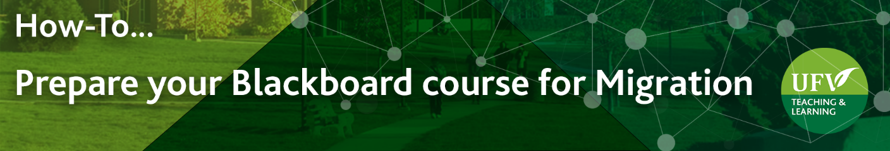

Prepare you Blackboard Course for Migration
It is important to review and organize your blackboard course to ensure the migration is successful, as Brightspace has some size limitations. The course content size has to be under Brightspace’s 2GB limit and must be organized using five (5) nested folders or less.
In this document, we will give suggestions on how to remove any duplicated content and files, reduce your content size and reorganize content in 5 nested folders or less.
- Log into myClass: https://ufv.ca/myclass/ and click on your Blackboard course

Check for any content area and items that are empty, duplicated or hidden from view and that could be deleted:
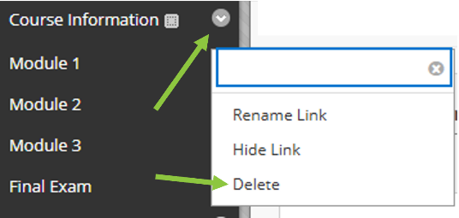
- To delete an entire content area, click on the down arrow near the menu name and select Delete.

In the new window, click on Delete Content, then confirm by clicking on Delete once more.
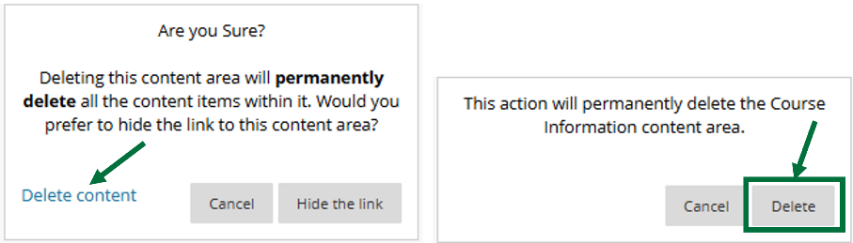
- To delete an entire folder or an item within a content area or folder, click on the down arrow near the folder or item name and select Delete. Click on OK to confirm.

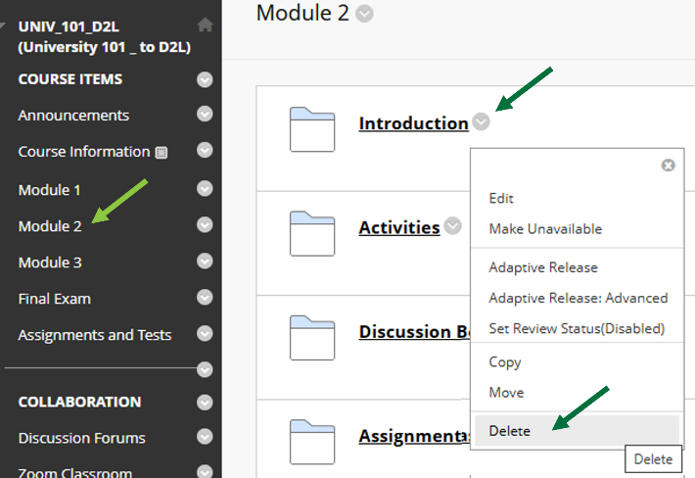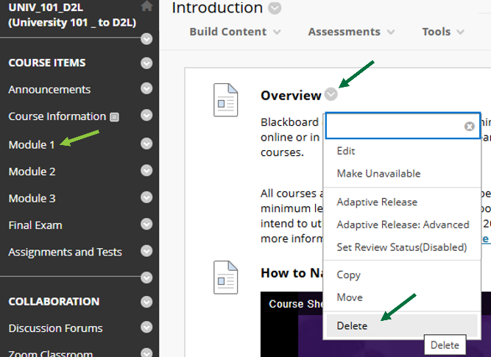

Check for tests that are not deployed and that could be deleted:
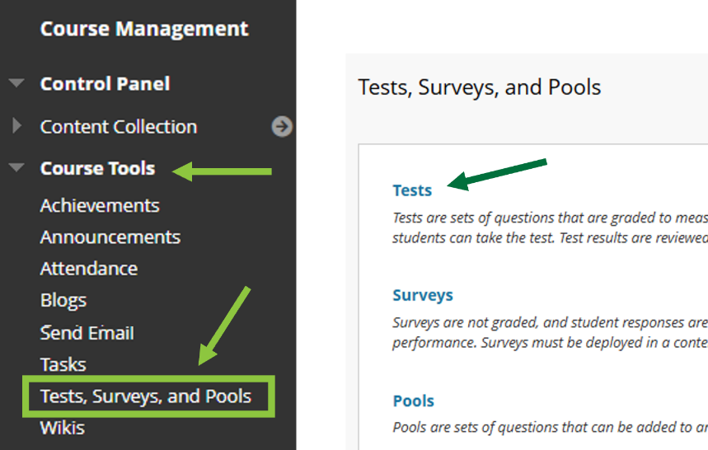
- In the left side menu, scroll down to Course Tools and select Test, Surveys and Pools and click on Tests.

- Tests that are not deployed in your course will show No in the deployed column.
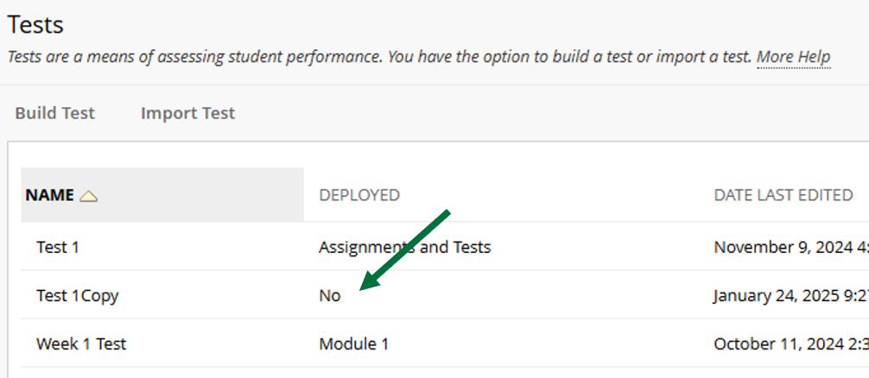

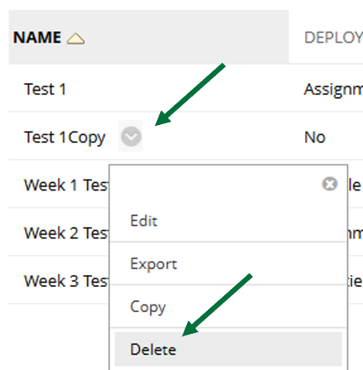
- To delete that test, click on the down arrow by the test name and select Delete. Confirm by clicking on OK in the new window.

Check for very large files in your course content collection that could be deleted or large video files that could be uploaded to Kaltura:
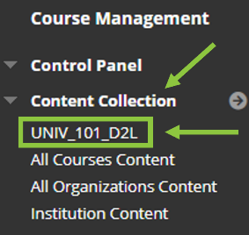
- In the left side menu, scroll down to Content Collection and select the first link, which is your course CRN or course ID. You will see the list of all the files that are in your course.

- Click on the SIZE menu two times to sort your files by size, showing the largest first.
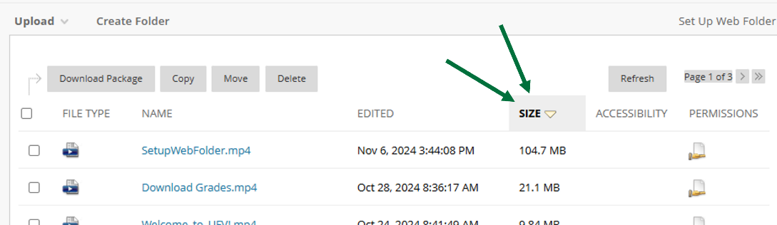

- If the large files are videos, it is strongly recommended to upload them to Kaltura instead. Click on this tutorial to learn how to Transfer Videos to Kaltura

If the large files are files that are duplicated (from a course copy), delete selecting the files and then clicking on the Delete button above the file list.
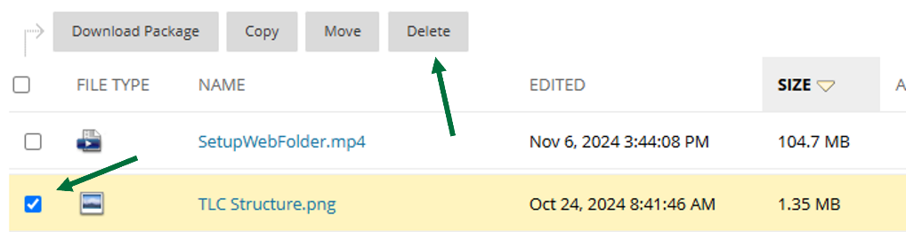
Check how many nested folders you course has, as only three nested folders and their content will be imported to Brightspace. If you have a fourth level of nested folder, that content will be lost in the transfer to Brightspace.
- To check how many nested folders you have in your course,
click on the Folder icon at the top of the left side menu.

A new window with your folder and items will appear. Enlarge it to view everything.
The first level of nested folders is the menu (often the course content menu).
The second level of nested folders is often your modules or weekly content.
You may have a third, fourth and fifth level of nested folders, especially if you use Module Pages.
If you have a forth level of nested folders, that folder and its content will not get transferred to Brightspace and content will be lost.
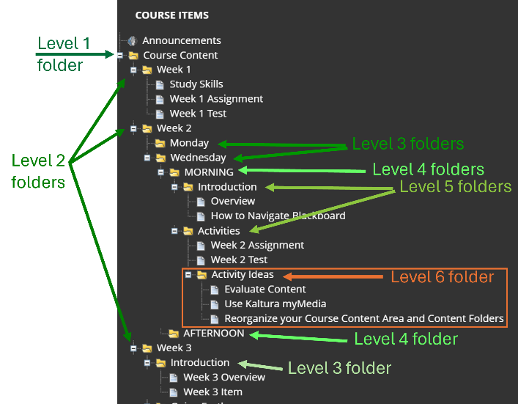
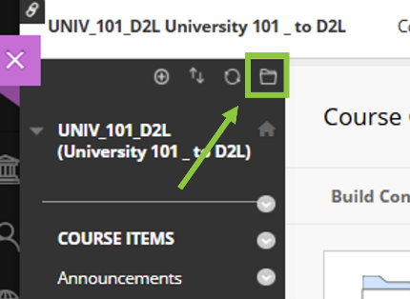

- To reduce the number of nested folders in your course, you can move folders a level down. In my example, I could move the Activity ideas folder in the MORNING folder.

To move a folder, click on the previous level folder (in my example, Activities).
Click on the down arrow by the folder’s name and select Move
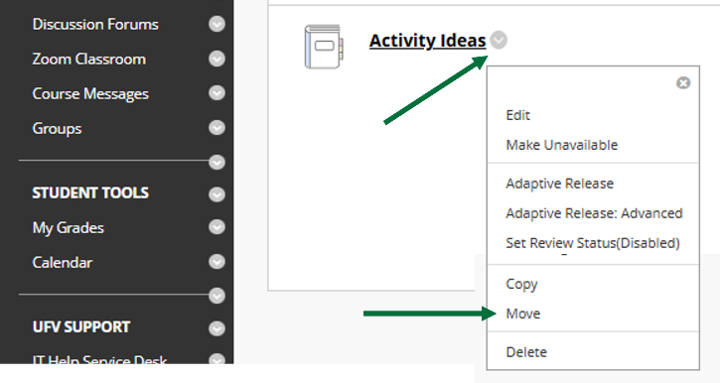

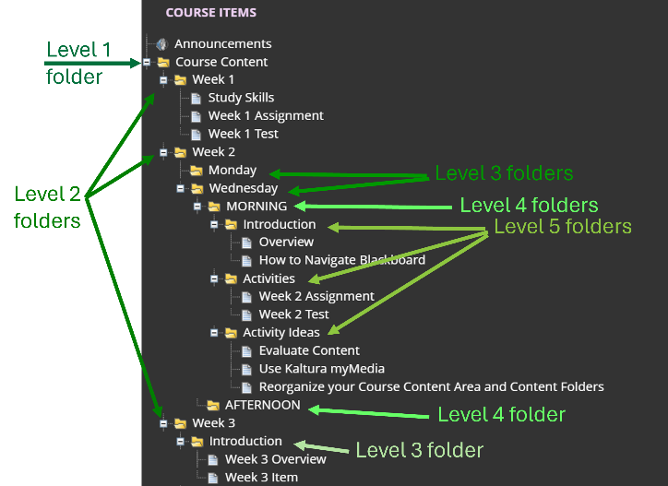
In the new window, click on Browse to select the Destination folder (in my example, Week 2), and click on Submit.

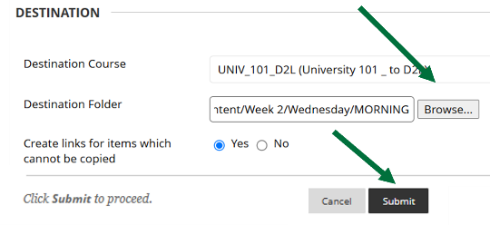
The folder is moved to the new location and I only have 3 nested folders.

- Another option to reduce the number of nested folders in your course, is to create new content area in the menu, instead of having just one. Note that this method involved moving many folders and/or items and is time consuming.

To create a new menu area, click on the round + icon at the top of the left-hand menu.
Select Content Area.
Give a name (for example Module 1) and click on Submit
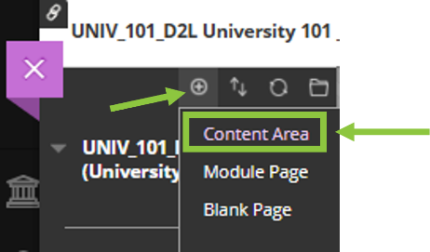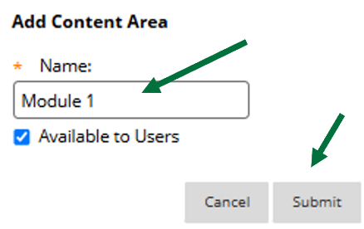

You may have to then grab and move the newly created content area to where you would like the menu to appear in the left-hand menu.
Then follow the steps described above to move the content (folders and/or items) to the new content area.

Looking for more tutorials? Check out our written How-To Guides at: https://www.ufv.ca/teaching-and-learning/Brightspace We also have video How-Tos at video.ufv.ca and you can always email us at asktlc@ufv.ca
