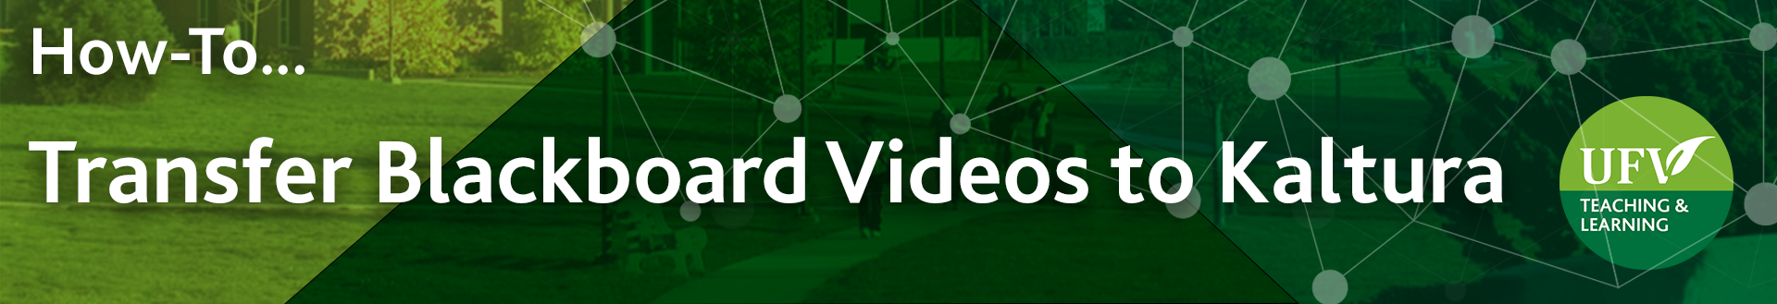

Transfer Blackboard Videos to Kaltura
You can transfer videos saved in Blackboard to Kaltura to reduce the size of your course so it can be imported to Brightspace. Kaltura is accessible from Brightspace and could be used as a video repository.
- Log into myClass: https://ufv.ca/myclass/ and click on your Blackboard course

To check if you have large videos saved in Blackboard:
- In the left side menu, under Course Management, click on Content Collection
and click on your course ID or CRN.
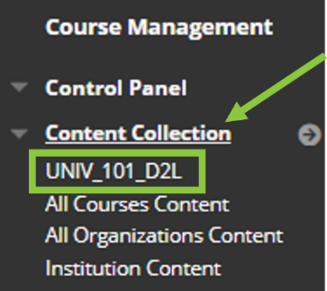

- In the menu above your files, click on Size twice to sort your files in decreasing order of size. If you have videos larger than 100MB, it would be best to move them to Kaltura.
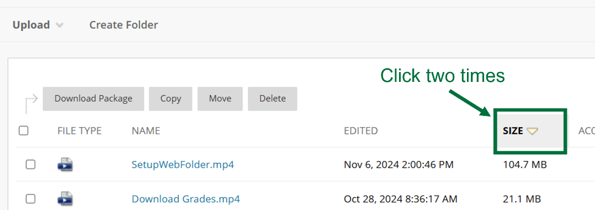

To find and download your blackboard videos in your course:
- Navigate in your Blackboard course to where the video is located.
You can recognize Blackboard videos as they do not have borders around them and the video controls are on the bottom part of the video. In contrast, Kaltura videos have borders around and the controls are green below the video (See table below).

Video saved in Blackboard  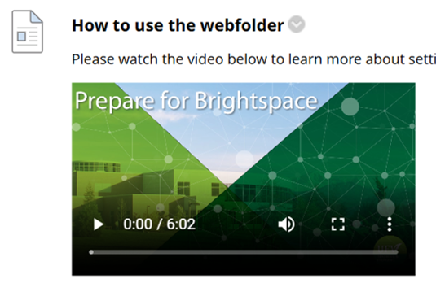 | Video saved in Kaltura  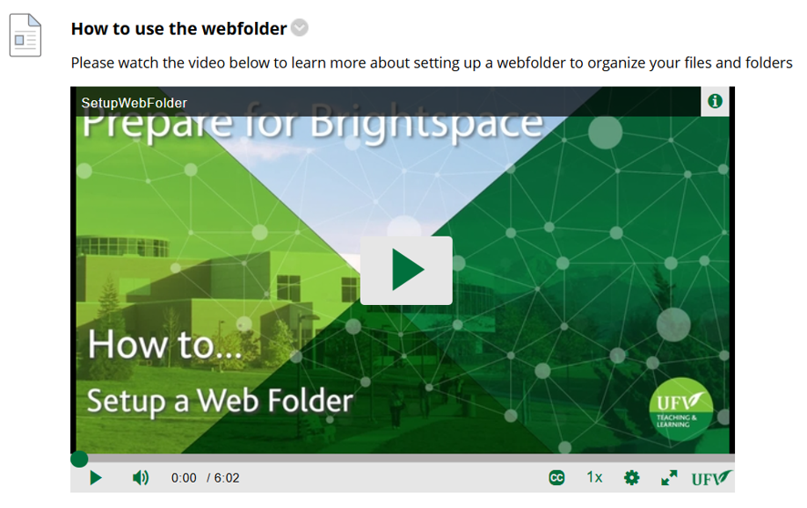

- Click on the ellipsis (more) at the bottom right corner of the Blackboard video
Select Download
The video will be saved in your Download folder or in the folder of your choice.
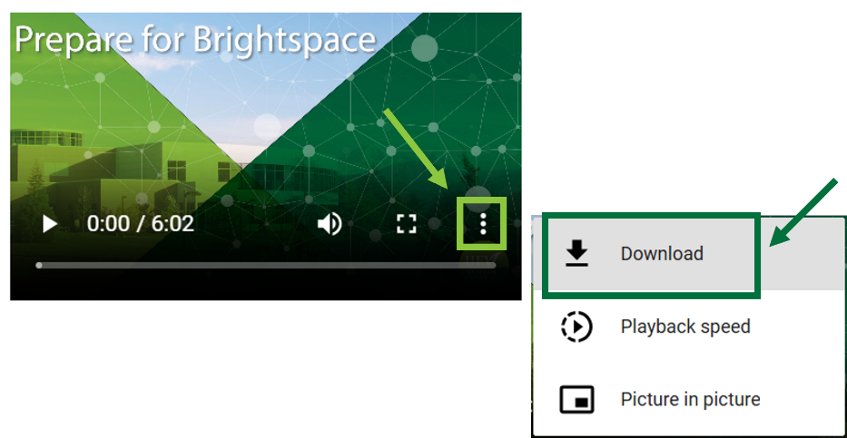

To upload your video to Kaltura and embed it in your course:
- In the item containing your Blackboard video, click on the arrow by the title
Select edit.
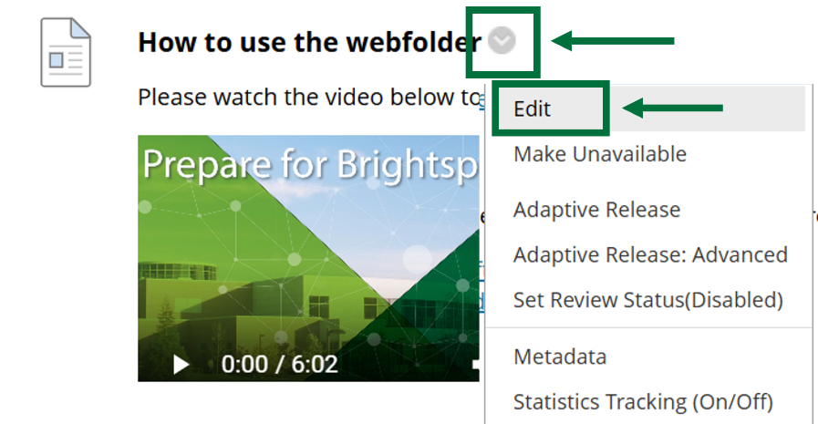

- In the text box, click on the Blackboard video to select it and
press delete on your keyboard to remove that video from your item.

- Click on the ellipsis to see more options in the text box,
Select the round + icon to Add content
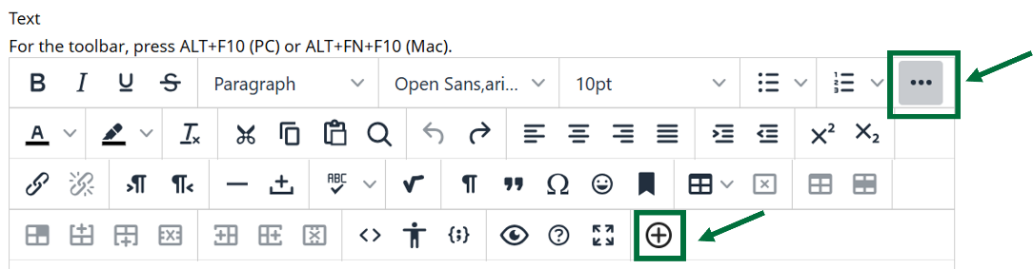

- Scroll down and click on Kaltura Embed LTI
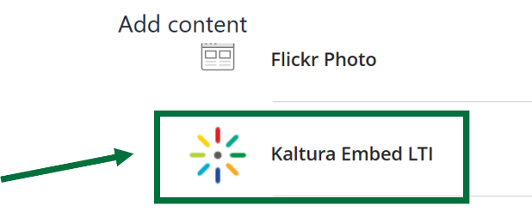

- Click on + Add new and select Media Upload
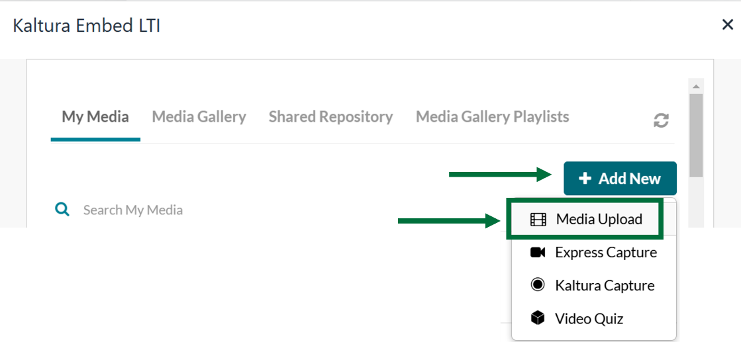

- Click on Choose a file to upload.
Find the video you just downloaded, select it and click on Open.
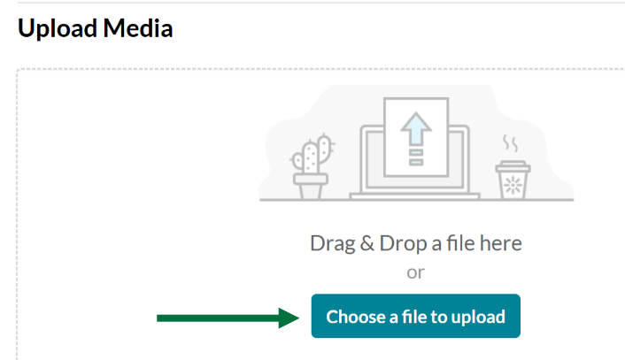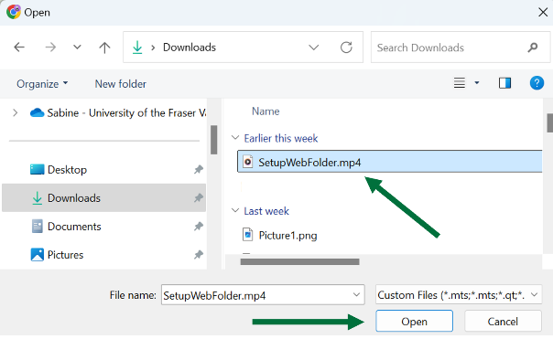

- Once the video is uploaded to Kaltura, click on </> Save and Embed
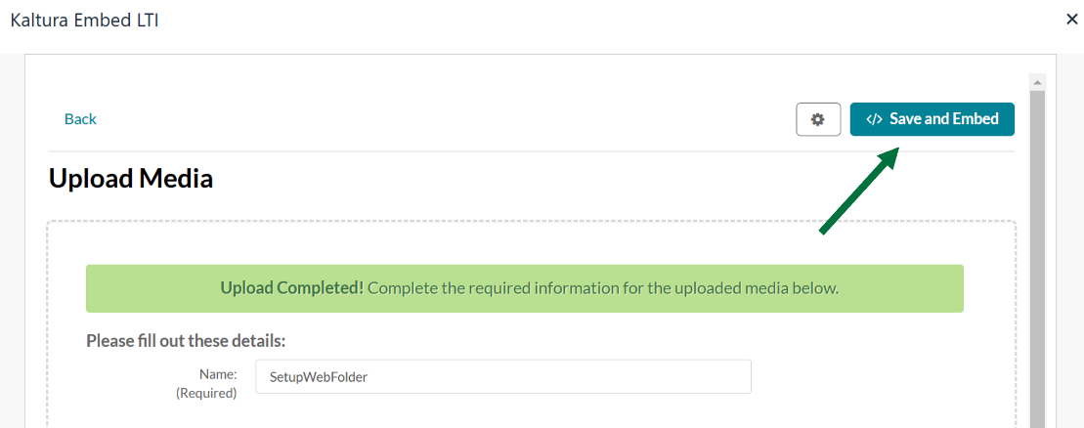

It may take a few minutes, but the video will appear. You can click on Click Here to refresh the video.

- Click on Submit to save your post.
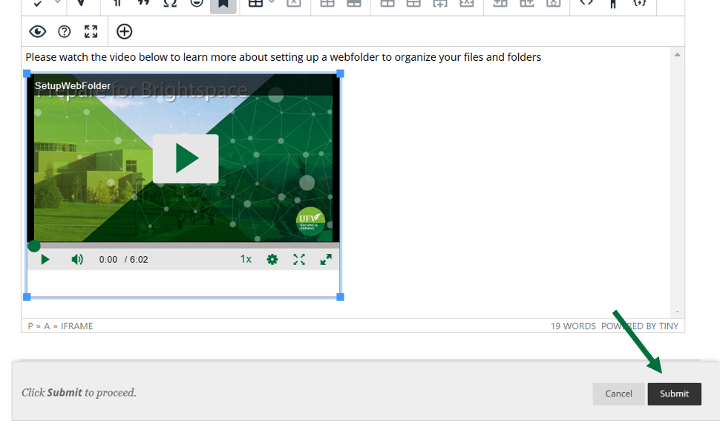
To delete your Blackboard video from your content collection and reduce the size of your course so that it can be imported to Brightspace:
- Go back to your content collection (In the left side menu, under Course Management, click on Content Collection and click on your course ID or CRN)

- Select your video and click on delete.
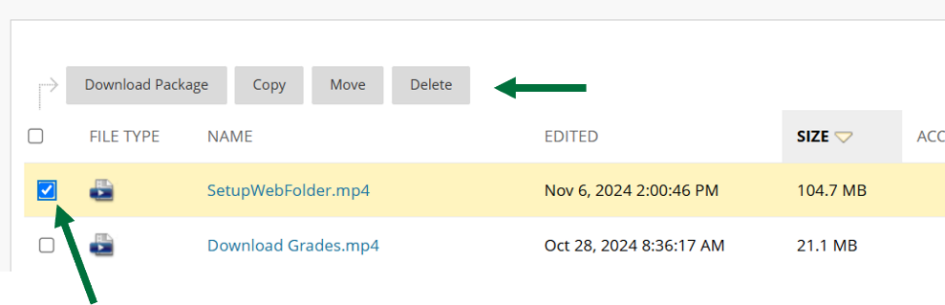

- Click on OK to confirm the deletion.
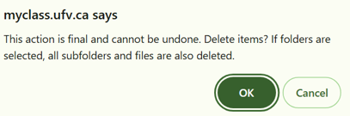

Looking for more tutorials? Check out our written How-To Guides at: https://www.ufv.ca/teaching-and-learning/Brightspace We also have video How-Tos at video.ufv.ca and you can always email us at asktlc@ufv.ca
