

# Download Grades from Blackboard

This allows you to download your student grades from Blackboard if you need to keep a copy for future records.

1. A black screen with white text

   Description automatically generatedGo to **Full Grade Centre**
2. A screenshot of a computer

   Description automatically generatedClick **Work Offline** and choose **Download**
3. Choose the data that you want to download.
   1. Full Grade Centre
      1. All grades for all assignments
   2. Selected Column
      1. Only download the grades for the selected column
   3. User Information Only
      1. Do not use this, user information is stored within Banner.
4. Choose the Delimiter Type options
   1. Choose Tab
   2. And do not Include Hidden Information.
5. Click Submit
6. Click Download
7. Navigate to your Downloads Folder and open the Excel spreadsheet
8. 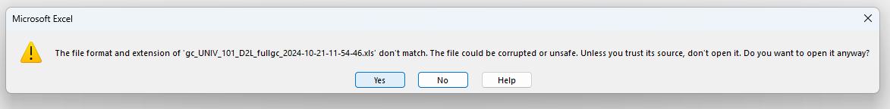Click Yes on the popup that appears
9. Click Save As… on the yellow bar that appears at the top. Or click File 🡪 Save As
10. A screenshot of a computer

    Description automatically generatedGive it a distinct file name that includes the class and the semester and change the Save as type to Excel Workbook
11. Click Save

Looking for more tutorials? Check out our written How-To Guides at: <https://www.ufv.ca/teaching-and-learning/Brightspace> We also have video How-Tos at [video.ufv.ca](https://video.ufv.ca/category/Brightspace/649086) and you can always email us at [asktlc@ufv.ca](mailto:asktlc@ufv.ca)

